HW 3
E1-a
- On average, associate professors make more money than assistant professors do, regardless of sex.
- On average, males make more money than females if they have the same rank.
- There are more male faculties than male faculties, and a majority of male faculties have the higher rank while more than 50% of female faculties have the lower rank.
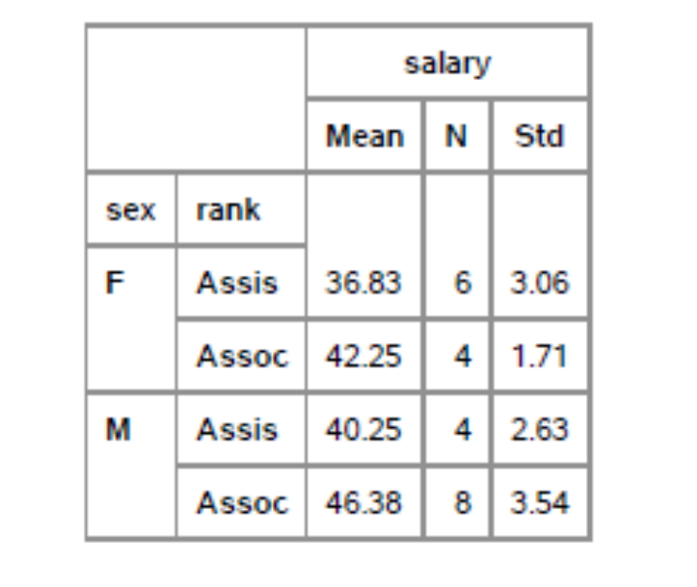

E1-b
- Both Type I test and Type III test show that the interaction effect has an F value of 0.07, and the p-value is 0.7951, which indicates that the interaction effect is not significant at the .05 level.
- The main effects of sex and rank are all significant looking at the sequential (TYPE I) and partial (TYPE III) SS (all p-values are less than .05).
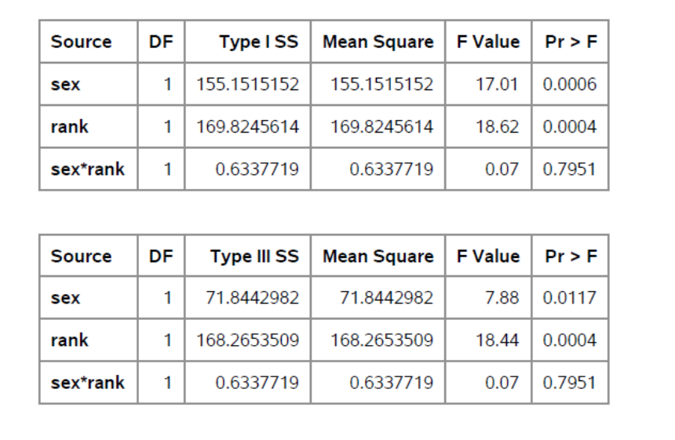
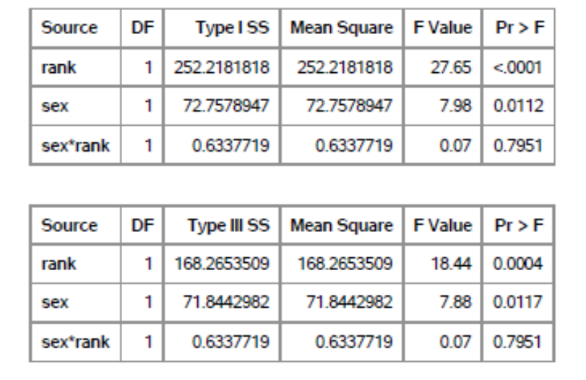
E1-c
According to the tables, the main effect of sex is significant when it is the only variable included in the model (p-value = .0005). The main effect of sex is also significant over and above rank (p-value=.0093)
The main effect of rank is significant when it is the only variable included in the mode (p-value<.0001)l. The main effect of rank is also significant over and above sex (p-value=.0003)
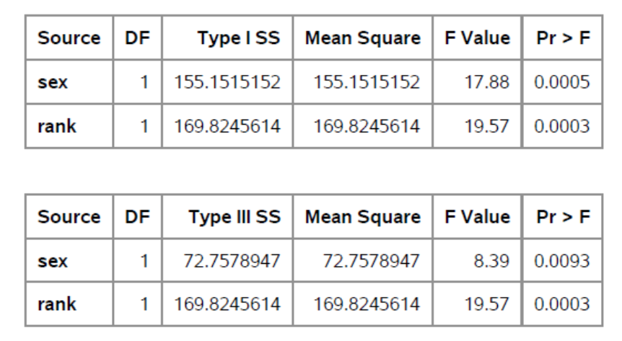
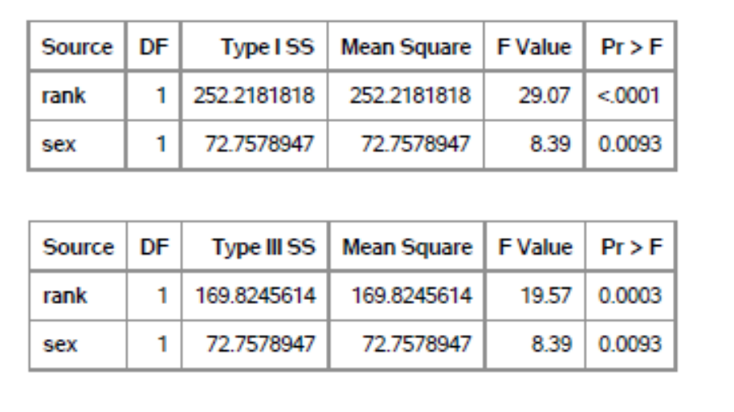

E1-d
The final model will be additive, which means there will be not interaction effect. The main effects of both sex and rank are significant at .05 level. This tells us that both sex and rank significantly affect faculty salaries; however, the interaction of the two variables does not affect significantly faculty salaries.
E2-a
X1:
R^2= .7558
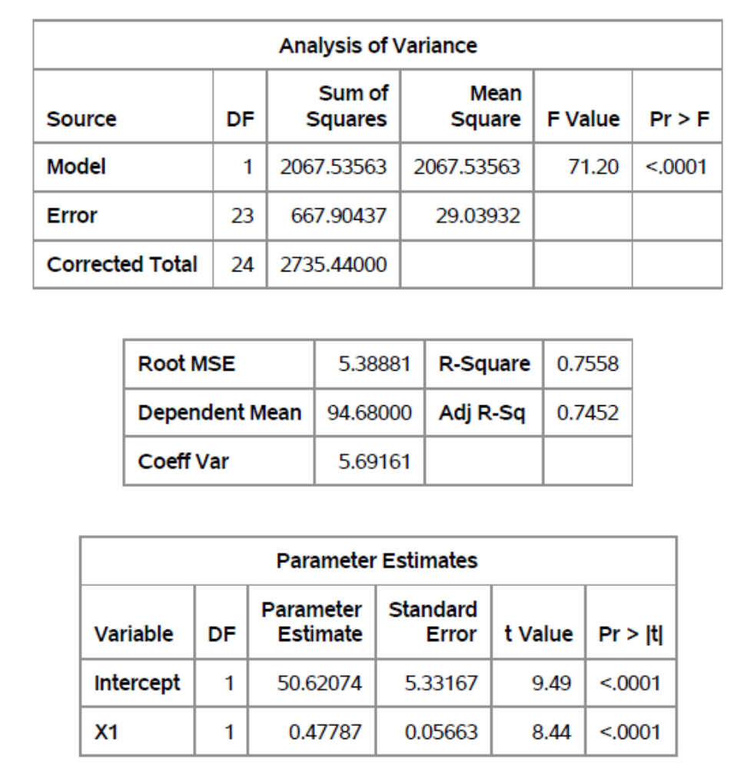

X2:
R^2=.1067
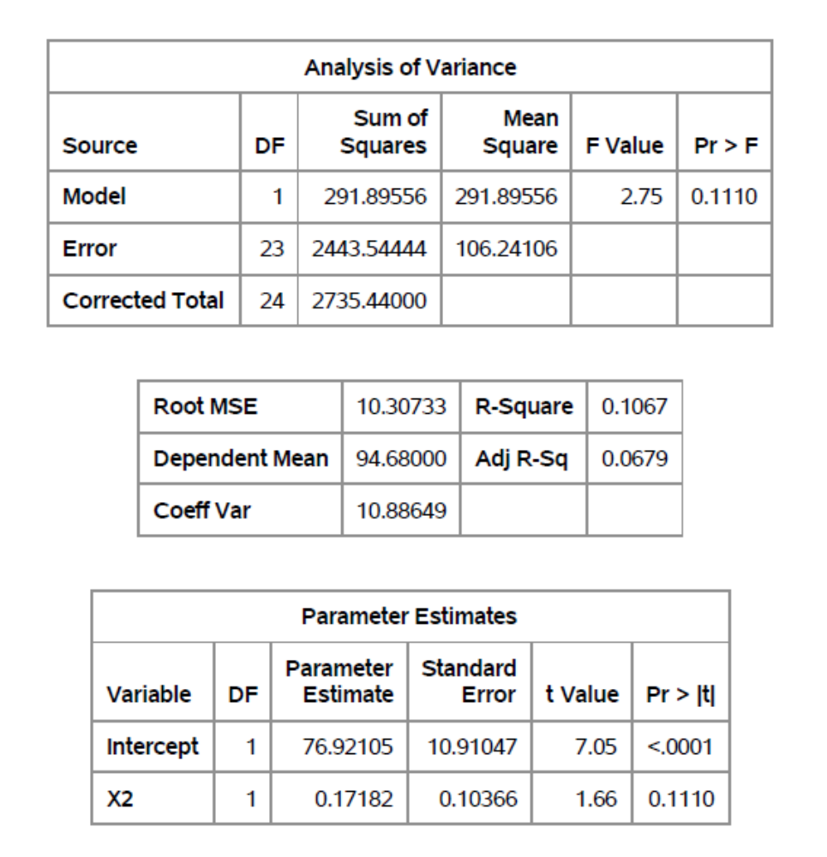

X3:
R^2=.1574
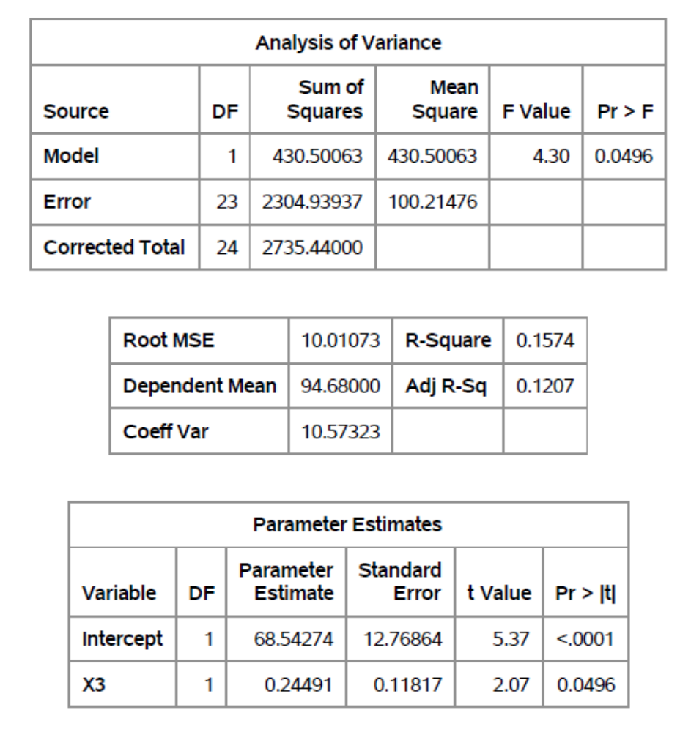

X4:
R^2=.6116
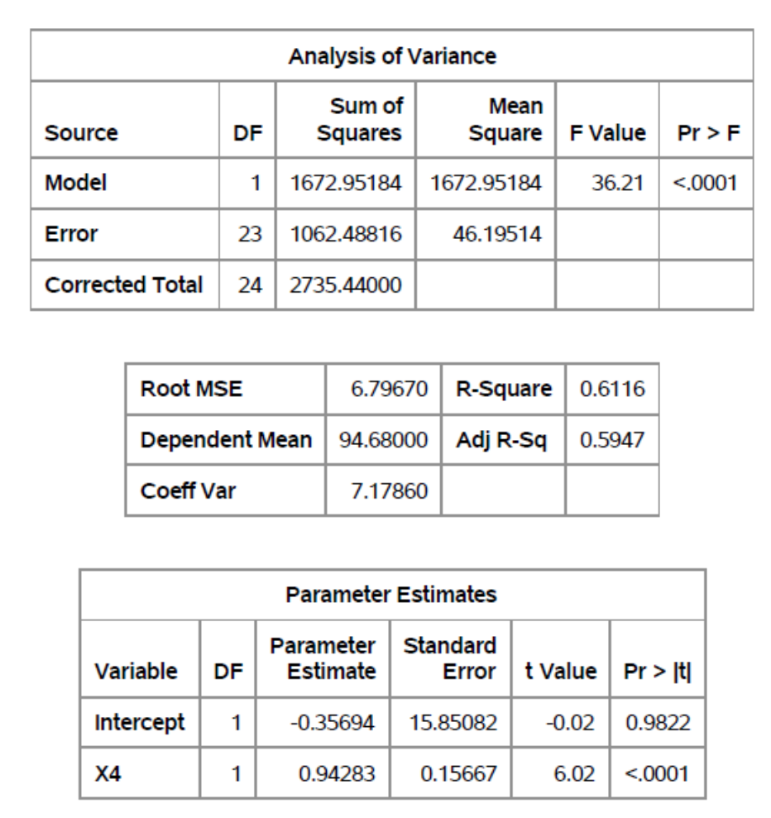
I would pick X1, because the model with X2 is not significant (p-value=.1110) and too small an r^2 value (r^2=.1067), the model with X3 has too small an r^2 value (r^2=.1574), and the intercept of the model with X4 is not significant (p-value=.9822).

E2-b
Observation No.2 has a zres value larger than 2, so it was dropped. All the other observations look fine, with Cook’s d being smaller than 1, leverage being smaller than .5, and studentized residual being smaller than 2.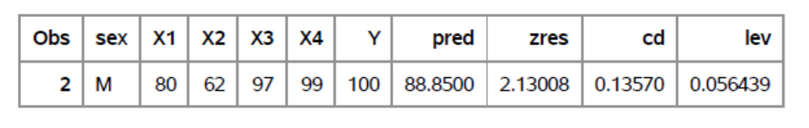
E2-c
After removing the outlier, I refitted the model:
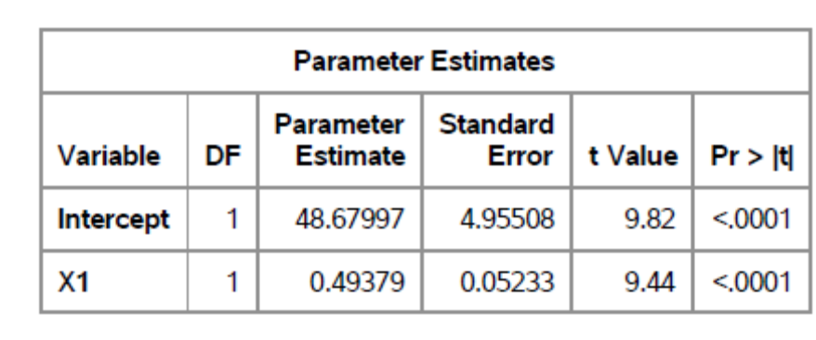
Model: 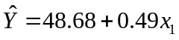
Interpretation: Employees that are 1 point higher than other employees in X1 test tend to have job performance that is .49 points higher. Employees who have got 0 on X1 test still tend to get 48.68 points on job performance.

